Session-1 Om vankar

1).Write a short paragraph in your own words defining what a 'program' is and give one real-life example from any app you use daily (like Instagram, Zomato, or Paytm).

Ans) A program is a set of instructions written in a programming language that tells a computer what tasks to perform. Programs help computers solve problems, process data, and perform useful actions for users. For example, when I open Instagram and like a photo, a program processes my action and updates the like count for that post.

2). List three popular programming languages you have heard of, and for each, mention whether it is usually compiled, interpreted, or can be both.<br><br><em><strong>Hint:</strong> Think of languages like Java, Python, and JavaScript.</em>

Ans)
Programming Language | Compiled / Interpreted
Python | Usually Interpreted
Java | Both (Compiled to Bytecode and Interpreted/JIT by JVM)
JavaScript | Usually Interpreted (JIT-compiled in modern browsers)

3) Draw a flowchart (on paper or using any online tool) for the process of booking a movie ticket on BookMyShow, starting from opening the app to receiving the booking confirmation.

Ans)

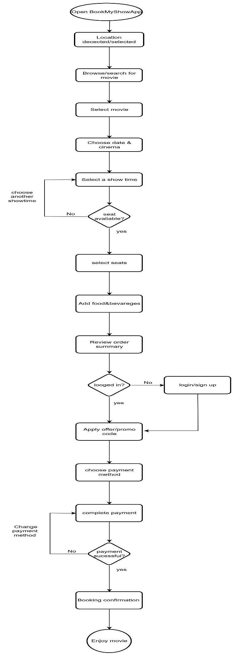

4). Write down the steps (as an algorithm, using simple numbered instructions) for ordering food on Swiggy — from opening the app to completing payment.

Ans)

- Start.
- Open the Swiggy app.
- Log in to your account.
- Enter or confirm your delivery location.
- Search for a restaurant.
- Select the restaurant.
- Browse the menu items.
- Choose the food items you want to order.
- Add the selected items to the cart.
- Review the cart and order details.
- Click on "Proceed to Checkout".
- Select a payment method.
- Complete the payment.
- Receive order confirmation.
- Track the order until it is delivered.
- End.

